HOWDY PARTNERS, WELCOME TO ALAMEDA COUNTY 4-H
2016 SMALL ANIMAL FIELD DAY 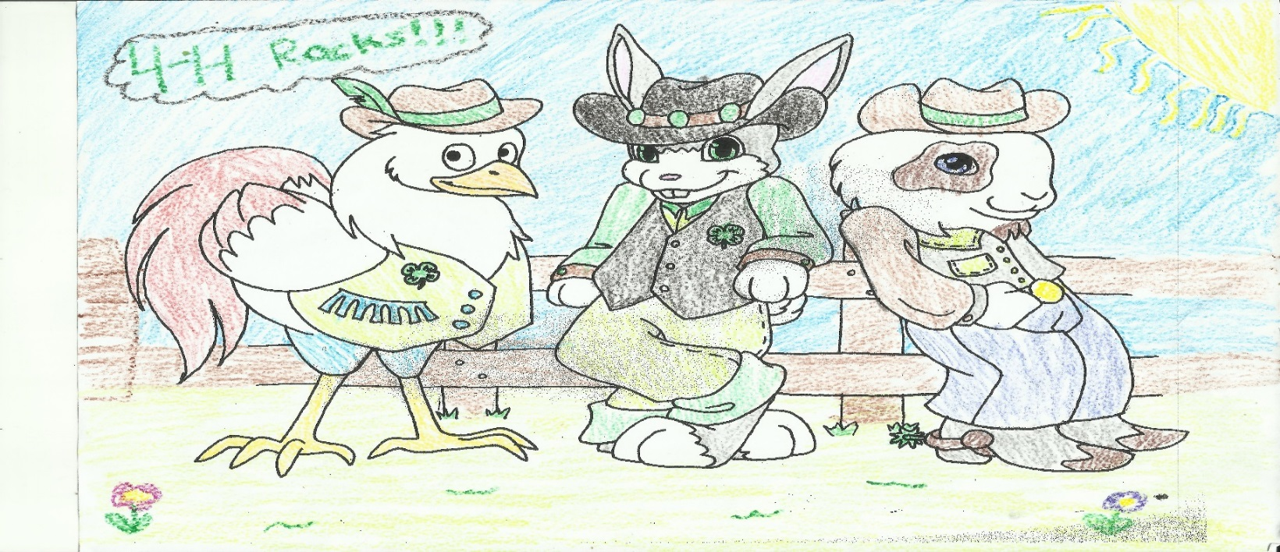

Theme is 4-H Wild West
10 am to 3 pm
Saturday, April 23, 2016

Booth Set Up 9 am
Rowell Ranch Rodeo Picnic Grounds – 9725 Dublin Canyon Rd., Castro Valley
OPEN TO PUBLIC
Pre - Register online http://4halameda.ucanr.edu
Challenge yourself!!! Learn about Small Livestock and Pets!
Mock Showmanship Clinics: Cavy, Poultry, Rabbit Cavy and Poultry Knowledge Tests
Cavy, Poultry, Rabbit ID Contest Cavy, Poultry, Rabbit Dress Up Contest Photo & Poster Contest
Species Booth Contest (Venue supply tables, Clubs supply POP-UPS , this is your BOOTH)
Presentations Dog Medalist Test Rabbit Medalist Test (TBD)
Games Door Prizes Snack Booth (Palomares 4-H)
It is the policy of the University of California (UC) and the UC Division of Agriculture & Natural Resources not to engage in discrimination against or harassment of any person in any of its programs or activities (Complete nondiscrimination policy statement can be found at http://ucanr.edu/sites/anrstaff/files/215244.pdf ) Inquiries regarding ANR’s nondiscrimination policies may be directed to John I. Sims, Affirmative Action Compliance Officer/Title IX Officer, University of California, Agriculture and Natural Resources, 2801 Second Street, Davis, CA 95618, (530) 750-1397.

Leadership Opportunities help out with the various Committees needed to put on a County Event sign up online or contact Jeff/Annette Robbins jrobbi637@comcast.net

