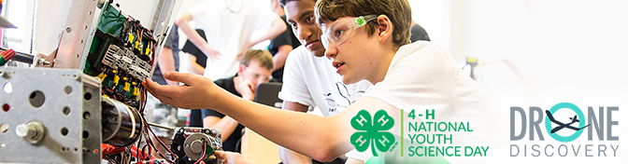 Are you ready for 4-H National Youth Science Day? Participating in the 2016 4-H NYSD Challenge is easy: Purchase the kit. Each challenge kit includes all the necessary items needed to participate in the challenge, including youth and facilitator guide books, and experiment materials. Kits are available for purchase now on the 4-H Mall. Register your event. Simply create a 4-H NYSD membership account to receive helpful resources and materials and see your local event showcased on our national online 4-H NYSD map. Join the conversation on social media. Share your event photos and videos using the the hashtag #4HNYSD. Your event could be featured nationally! Buy the official Drone Discovery t-shirt. Visit the 4-H Mall to get this cool new tee to wear during your 4-H NYSD event and beyond. So what are you waiting for? Get ready to take flight in this annual science phenomenon!
  - Volume 1 | Issue 1
September 2, 2016

4-H Blast
INVITE 4-H CLUBS AND OTHER ORGANIZATIONS TO PARTICIPATE IN YOUR EVENT
About 4-H NYSD Developed by Cornell University Cooperative Extension, the 2016 4-H National Youth Science Day Challenge will explore how remote sensing can be used to solve real world problems while learning concepts like flight dynamics, forces of flight, basic computer coding, as well as following federal regulations while operating drones. The 9th annual 4-H NYSD Challenge will be held on Wednesday, October 5, 2016, and will bring youth together from all around the nation to complete this single, innovative activity. Be sure to visit www.4-H.org/NYSD for fun, engaging STEM content, and to access resources and materials. 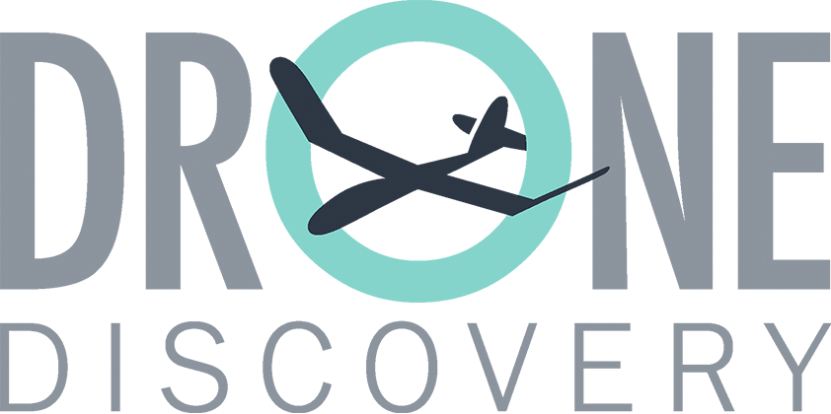 National Partners National Sponsor Thank you to our national partners, HughesNet, Lockheed Martin and U.S. Cellular, and national sponsor DJI.

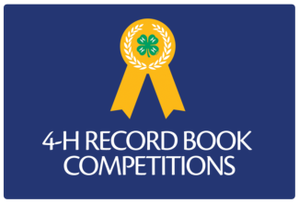
Record Book Evaluation - September 10, 2016
The Incentives and Recognition committee is preparing for Record Book Evaluations. Contact your Community Club Leader to offer help to evaluate all the wonderful books. There will be an orientation before we begin. Contact Barbara Butko for more information at barb.butko@gmail.com
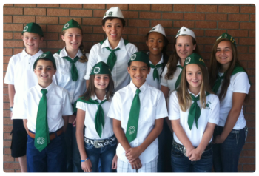
Save the Date – Alameda County 4-H Leadership Day, Nov. 19, 2016 Come learn the Leadership skills needed to perform your duties as a club officer. More information coming.

