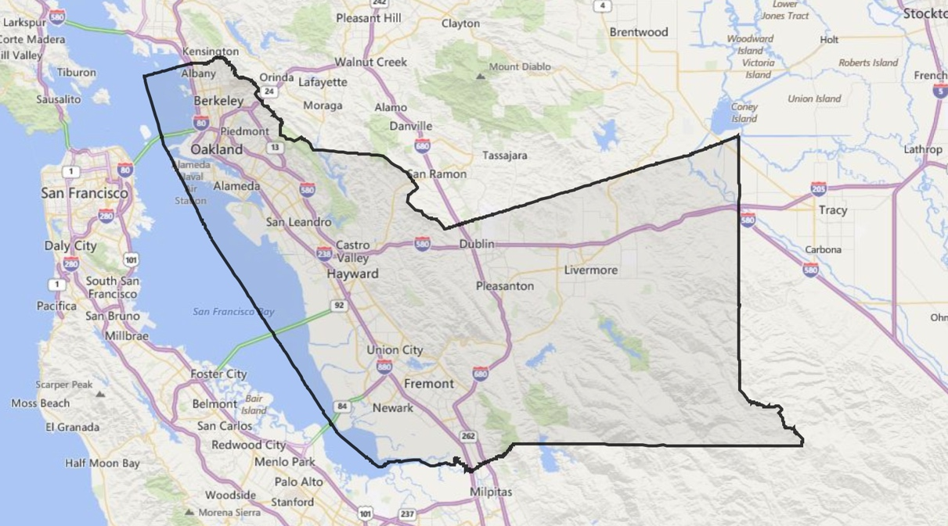
Countywide Projects
Domestic Exchange
  - Volume 1 | Issue 2
November 3, 2016

4-H Blast
County Projects are open to all Alameda County 4-H members
Remember to read the project description for any age restrictions
To sign up for a County wide Project, add the club to your existing profile and then the project will appear in the drop down menu so you may add it. Contact your Community Club Leader for a list of projects offered

4-H State Exchange Alameda and Contra Costa County
Add the club Countywide, Select Project Domestic Exchange

Hello, my name is Selma Michael and together with Marnie Hascall we are reestablishing the Domestic State Exchange Project. It is a county project and is open to any member over the age of 12.

The project does entail a lot of parental involvement. A lot of fund raising and traveling as well as hosting. However, it is an adventure your members will never forget. They make friends from all over and many of them carry on those correspondences into adult life. Not to mention seeing how other 4Hers live and interact.
We are taking sign-ups now and would like to get our first meeting going by the end of the month.
Please feel free to call me if you have any questions at all. I have been involved with State Exchange for a number of years and would love to chat with you. I know we are all busy. I work two jobs and I understand not enough hours in the day. But please take a few moments to pass this along to your friends.

Selma Michael
Bayside 4-H Project Leader
510-517-2346
Countywide Projects
Sunol 4-H Club Dog Project
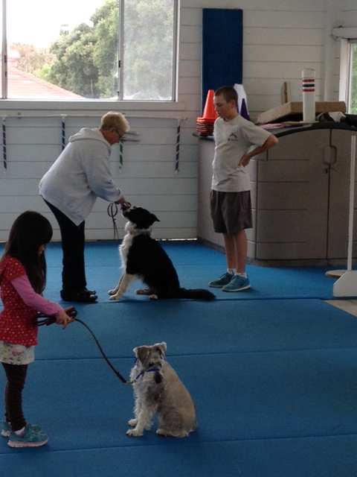

The Sunol 4-H Dog Project
Add the Club: Sunol 4-H Club, Select Project Name: Dog

The Sunol 4-H Dog Project finished up a great year, with both owners and their canine's not only achieving a better respect of each other, but also gaining a better understanding of the proper way to 'ask' your pet to do what you what them to do in order to achieve the desired results. Abbey Buckler, for the 2nd year, showed her Shetland Sheepdog, 'Bandit', in Obedience at the Fair.

We're throwing it out to the county to gauge the interest level in continuing the project moving forward.
We would propose it to run a little differently than we did this year - certainly a little more structured.
We would continue to hold classes at Happiness Country Kennels in Sunol, but on Thursday nights at 7:30 ~ 8:30 p.m., starting in February (actual dates TBA), for 7-consecutive weeks. There would be stipulations in order to join the class:

* The classes would be geared to show your dog at Fair in the summer (2017), so it would be a requirement that you will register your dog for Fair.
* Attend 'Dog Field Day', usually held in late May.

We would need a minimum of 5-members in order to hold the class. So were opening the project to other local 4-H clubs as well.

Consider over the next few weeks whether you would like to join, and are willing to make the commitment. Sign-ups can be online. In November, I will contact those who've signed up to discuss the details.

Sunol 4-H Dog Project team

Bret & Abbey Buckler
bret_b@hotmail.com

4-H Adult Volunteer Development
4-H State Leaders Forum in Santa Rosa
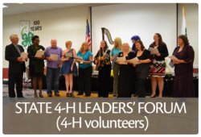

This fall, November 11th-13th, to be exact, in Santa Rosa (pretty close, yes), will be the annual State Leaders Forum (SLF). For those of you who aren't familiar with it, it's the Statewide Adult Volunteer Development Conference. I know about it because 1) I went last year, and 2) I'm the Registrar for this year's event. Note: attendance does not require that you lead it the next year....

It's a must do if:
1) You're an Adult Leader with any amount of experience (0-99 years of experience) under your belt;
2) You want to know how Santa Barbara raised $200K in their fundraising last year;
3) You want to better understand what constitutes an effective adult-youth partnership;
4) You want to know how to deal with kids on the spectrum in a way that works, whether you're talking about gender and identity (LGBTQIA), or social emotional (MESH), or ADD;
5) You want to catch an excellent presentation on engaging teens based on the presenters 7 years of experience leading leadership projects with 25+ teens actively involved in the project;
6) You want to attend a great presentation on better understanding your own personality traits or those of others, to improve your leadership and more;
7) You want to know what the State Leader on Animal Science identifies as the best curriculum resources out there - and how best to teach so that youth can learn;
8) Your club meetings are boring and you want to be one of the participants who walks away with skills on how to build a powerful Club meeting agenda that will involve every club member from the youngest to the oldest, strategies for including non-officers in the meetings and building mentoring opportunities between officers and other club members.

If you said yes to any of the above - this conference is for you! And hey - there are 18 great workshops... so you're going to have a hard time choosing which 3 you most need to attend.

Once again, it's close - it's $125 for Saturday only, which is when you get the workshops plus 1 (of the event's 3) impressive conference speakers, 3 meals, and more experiential learning than you really should have to absorb in a day.) If you haven't attended SLF before, you can consider applying for a partial scholarship. Although County Council is not made of money, there's a little in there for conferences like this one, and any little bit helps. Also, you can deduct expenses related to volunteer training from your taxes, per the IRS.

Or you might consider attending the full conference - from Friday, November 11th - starting at 3pm till Sunday at 11am, because there's more happening across the weekend that we can all benefit from. And, because there isn't one for another 2 years - and the next one is likely to be in 2018-2019 and we don't know where yet (probably no somewhere as close).

Attached is a tentative schedule and more information on the workshops. There is also more information at the SLF website at http://4h.ucanr.edu/4-H_Events/SLF/.

Feel free to contact me with any questions at slf2016reg@gmail.com.

Thank you,
Brenda

Record Books
Start Now. Do not wait but if you do, catch up over Winter Break and Spring Break

Online Record Books
The site that has short videos and to the point instructions is http://ucanr.edu/sites/4horbhelp/

Here you will find:
Getting Started
Personal Development Report
Annual Project Report
Leadership Development Report
Submit and Print
Adults
Staff
FAQ
Access ORB
ORB Bug Report

Another site is Resources for Youth at http://4h.ucanr.edu/Resources/Members/
How would you Vote?
Help another 4-H member from Tennessee

National Citizenship Project Participation
My name is Anne Eddins and I am conducting an election poll as part of my 4-H citizenship project in TN. I have lots of TN voters but I'd really like to get responses from all over the US. Anyone school age from 6-17 may vote. No personal information is collected. Voting is now open and will end the evening of Nov. 8…..Voting Day!
Please consider sharing the below link with your friends

https://www.surveymonkey.com/r/HSTYHYN

Thank you so much!
Anne Eddins, 7th Grade, Knox County 4-H

