4-H Office closed for Winter Break
The 4-H office will be closed during the Winter Break from Friday, December 23, 2016 to January 2, 2017. We will be back on Tuesday, January 3, 2017.
Help with short Videos for Nutrition Program in Contra Costa County
Attention Video Producers and Stars 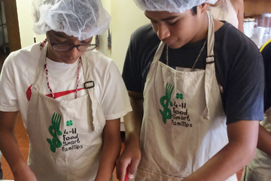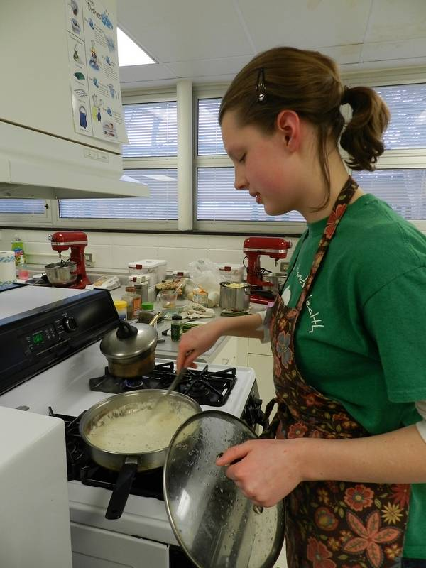

The Contra Costa and Alameda County Cooperative Extension Healthy Eating programs would like to recruit 4-H middle or high school teens to produce short videos of EatFresh.org recipe preparation with food/kitchen safety tips.
Design: The teens would video the steps to prepare select recipes from the EatFresh.org collection. They would also provide food safety and kitchen safety tips during the preparation of the recipe. The EatFresh.org Program Coordinator, Erin Franey, offered to help facilitate the initial filming. The number of videos to be produced-TBD
Relevance and Impact: The videos would be posted on the EatFresh.org website and be available for the public to view. The videos would be a nice resource for both the Hunger Attack and LOMO module. The teens would gain experience producing videos while learning about healthy eating on a budget. The project would enhance our relationship with Leah’s Pantry and promote UC ANR programs. A potential UC Delivers or other publication could evolve from this project.
Please contact me if you would like to participate.
  - Volume 1 | Issue 3
December 19, 2016

4-H Blast
Cheryl Fraser at cyfraser@ucanr.edu

Food Network is Now Casting for Season 2 of 'Kids BBQ Championship'!

Jennifer Sternberg
Senior Casting Associate
Kids BBQ Championship - Season 2
212-359-9463
jsternberg@jscasting.com
JS Casting Inc.

Summer Job Opportunity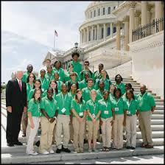

CWF Program Assistants needed

Do you know a college student who has a passion for government, history, political science, education, public speaking, or leadership? Do they have a passion for working with young people? If this brings someone to mind, encourage them to apply for the position of Program Assistant (PA) at National 4‑H Conference Center!

Application deadlines are quickly approaching and we want to give 4‑H alumni and collegiate 4‑H’ers an opportunity to apply for this amazing opportunity this summer. Our PA’s will be making a difference in the lives of thousands of high school-aged students from all over the United States while working for our Citizenship Washington Focus Programs (CWF) in Washington, D.C.

CWF Program Assistants will:

- Develop and facilitate a unique program experience for over 1,500 high school aged 4‑H’ers from across the country in Washington, D.C.
- Lead CWF delegates in experience based citizenship curriculum through tours and workshops
- Develop and refine teamwork, critical thinking, and problem solving skills in a fast paced and fun environment
- Become licensed D.C. tour guides
- The CWF PA experience begins in mid-May and ends in late July

APPLY

If you know a college student looking for an internship or credit towards graduation, please share this email.

More details about this program and application materials can be found on our website. If you have any questions, please contact Kelsey Conklin, kconklin@4hcenter.org.

Best,

Kelsey Conklin

Educational Programs Specialist

California State 4-H social media
Follow us on social media for the latest updates on 4-H in California.
Facebook
@California4H
@CaPrograma4H (Spanish)
Twitter
@California4H
Instagram
California4H
YouTube
California4H

