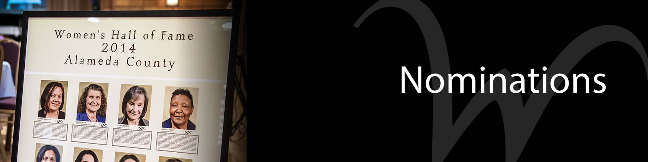
  - Volume 1 | Issue 5
January 19, 2017

4-H Blast

Alameda County Women's Hall of Fame Nominations Needed
Nominations needed
Deadline Jan 20th
My name is Hayley and I am reaching out for Alameda County is looking for youth nominations (11th & 12th grade) for the 2017 Alameda County Women’s Hall of Fame.

The Alameda County Women’s Hall of Fame is an event held each year to honor outstanding local women for their contributions to our community. The Women’s Hall of Fame supports women, youth and families by making charitable donations to community-based organizations in Alameda County. The Women’s Hall of Fame has a youth scholarship called “Leading the Way,” which helps propel young leaders to meaningful civic engagement.

General Characteristics:
· Each year, the Women’s Hall of Fame Youth category looks for female high school students in 11th and 12th grade demonstrating leadership and making a difference in the community.
· The nominee is successful in overcoming personal and/or professional obstacles
· Is a role model for youth, women and men in Alameda County who strive to achieve their own success
· Has benefited the Alameda County community through her volunteerism, engagement and initiative

If you know of someone you would like to nominate (for youth or a different category), applications can be submitted through the nominations page here: http://www.acgov.org/whof/nominations.htm
Deadline for nominations: Friday January 20, 2017

Please share with your networks, and feel free to reach me if you have questions.

Thank you!
Hayley Laity Hayley.Laity@acgov.org

Dear 4-H Shooting Sports Enthusiast:

The California State 4-H Shooting Sports Committee will be hosting a meeting regarding updates to the program in Merced County on Saturday, February 25, 2017. This meeting will cover a variety of items that are of interest to shooting sports leaders and teen leaders. This will be the first in what they hope to be a series of meetings to take part around the state. Attached you will find a schedule of the day’s events and the schedule for the second (optional) day of range rotations on Sunday, February 26, 2017. There is no cost to attend but you MUST register online using the link below.
https://ucanr.edu/survey/survey.cfm?surveynumber=19605

4-H Shooting Sports Workshop
Rifle Discipline - Bakersfield, CA
Saturday, March 18, 2017 – 8:00am to 6:00pm
Sunday, March 19, 2017 – 8:00am to 4:00pm
A 4-H shooting sports workshop for the rifle discipline will be held at the UC Cooperative Extension Office, 1031 S. Mt. Vernon Avenue in Bakersfield. Participants must attend both days of training to receive certification. Upon successful completion of the course, the participant will be certified as a rifle trainer and can lead a rifle project at the club level or serve as county trainer to certify other leaders. There is no cost for the course. To register for the course or receive more information, contact John Borba at: jaborba@ucanr.edu

College of Agriculture and Environmental Sciences Field Day
The UC Davis, College of Agriculture and Environmental Sciences Field Day will take place March 3-4, 2017 at UC Davis. This field day is open to both FFA and 4-H members. 4-H members may compete in any of the contests offered. Please note that the Livestock Judging, Poultry Judging and Dairy Judging contests are considered State qualifiers to attend the National events.

Registration Deadlines
- December 2nd - Online Registration opens.
- February 3rd - Online Registration Deadline - Payments must be postmarked by this date. A $25 late fee for payments postmarked after this date will be enforced.
- February 10th - Agriscience Fair and Job Interview materials due.
- February 10th - Online registration closed - Late registrations will no longer be accepted.
For more information about the event, please visit: http://www.caes.ucdavis.edu/connect/events/field-day

4-H Election Results
As you may remember, Anne, a 4-H member in Knox County Tennessee, conducted an informal election for 4-H youth to correspond to the National Presidential election. These are her results:

“I received votes from all of the states but 6 and 694 votes total!

The most popular vote for the 4-H-ers was Donald Trump. In the actual election Hillary won that vote. For the electoral college the 4-H poll and the election where the same; Donald Trump won both.

What was interesting was that some of the state polls were different than the election. These states came out as Trump in the 4-H poll but were really Hillary states: Cal., Ill., Maine, Mass., Min., Nev., R. I. and Vir. These states came out as Hillary but were really Trump states: Geo., Iowa, W.V. and Wis.”

Congratulations to Anne for completing such an amazing 4-H project!

Color Me Green 5K Run
Please let us know if your county is planning on hosting a Color Me Green 5k Run this year HERE. The Healthy Living Leadership team has been working on putting together some new materials for you to use; as these resources are available I will share. In the meantime, please visit the CMG website.
I look forward to supporting you in planning the CMG runs for 2017.
Happy running!
Thank you,
Anne

CWF Program Assistants needed
Summer Job Opportunity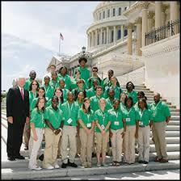

Do you know a college student who has a passion for government, history, political science, education, public speaking, or leadership? Do they have a passion for working with young people? If this brings someone to mind, encourage them to apply for the position of Program Assistant (PA) at National 4‑H Conference Center!

Application deadlines are quickly approaching and we want to give 4‑H alumni and collegiate 4‑H’ers an opportunity to apply for this amazing opportunity this summer. Our PA’s will be making a difference in the lives of thousands of high school-aged students from all over the United States while working for our Citizenship Washington Focus Programs (CWF) in Washington, D.C.

CWF Program Assistants will:

- Develop and facilitate a unique program experience for over 1,500 high school aged 4‑H’ers from across the country in Washington, D.C.
- Lead CWF delegates in experience based citizenship curriculum through tours and workshops
- Develop and refine teamwork, critical thinking, and problem solving skills in a fast paced and fun environment
- Become licensed D.C. tour guides
- The CWF PA experience begins in mid-May and ends in late July

APPLY

If you know a college student looking for an internship or credit towards graduation, please share this email.

More details about this program and application materials can be found on our website. If you have any questions, please contact Kelsey Conklin, kconklin@4hcenter.org.

Best,

Kelsey Conklin

Educational Programs Specialist

California ReLeaf
In Sutter-Yuba Counties, we have had youth that help with tree planting activities with an organization called California ReLeaf. I have been asked by California ReLeaf to help spread the word about Arbor Week and the Trees Are Superheroes contests to 4-H members throughout California.
Here is a link to the contests sponsored by CAL Fire and California ReLeaf: http://arborweek.org/for-educators/ the contest deadline is February 14. More information about California ReLeaf can be found on their website: http://californiareleaf.org/
Please spread the word to your leaders and members that California Arbor Week is March 7-14.
Find complete information and activities online. www.arborweek.org
Thank you for your help!
Tracy Bishop
Cooperative Extension Sutter-Yuba Counties
142A Garden Highway
Yuba City, CA 95991-5512
530-822-7515
tmbishop@ucanr.edu

California State 4-H social media
Follow us on social media for the latest updates on 4-H in California.
Facebook
@California4H
@CaPrograma4H (Spanish)
Twitter
@California4H
Instagram
California4H
YouTube
California4H

