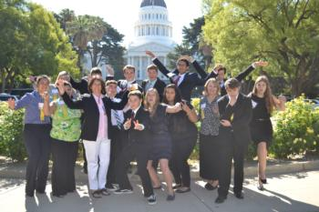
California Focus 2017
Sacramento
  - Volume 1 | Issue 6
  - Alameda County 4-H
  - February 24, 2017

4-H Blast

Alameda County

Experience California’s government in action by participating in the legislative, political, and judicial processes. California Focus combines hands-on participation in workshops, debates, simulations, tours, and fun activities.

June 16-20, 2017

Who can attend Youth ages 14 - 19. Youth must be at least 14 years old by the time of California Focus.

All Delegates and Chaperons receive a scholarship from Alameda County. The amount is $249.00 Cal Focus delegates and $499 for required chaperones. When you register, pay $250.00 plus incidentals (parking, t-shirt) Alameda County 4-H will send remainder of payment by due date
Youth Registration Deadline April 3, 2017
Adults can apply to chaperone this event.

Continued next page

Location
Set in Sacramento, California's capital, participants will tour the State Capitol building, Governor's Office, and 3rd District Court of Appeals. Workshops and lodging will be at the Holiday Inn Capitol Plaza, 300 J Street, Sacramento, CA.
For more information click here or contact Jenna Colburn at jcolburn@ucanr.edu

California 4-H Update Newsletter

Subscribe to receive the California 4-H Update, our monthly newsletter! Stay informed on upcoming events and opportunities for 4-H'ers and volunteers.
Subscribe today!
The newsletter is emailed once a month to 4-H members, volunteers and supporters. Members and volunteers can choose to subscribe when they enroll.
If you have questions about the newsletter, please contact Darlene Ruiz at ca4h@ucanr.edu or 530-750-1334.

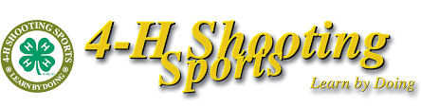

4-H Shooting Sports Workshop
Rifle Discipline - Bakersfield, CA
Saturday, March 18, 2017 – 8:00am to 6:00pm
Sunday, March 19, 2017 – 8:00am to 4:00pm
A 4-H shooting sports workshop for the rifle discipline will be held at the UC Cooperative Extension Office, 1031 S. Mt. Vernon Avenue in Bakersfield. Participants must attend both days of training to receive certification. Upon successful completion of the course, the participant will be certified as a rifle trainer and can lead a rifle project at the club level or serve as county trainer to certify other leaders. There is no cost for the course. To register for the course or receive more information, contact John Borba at: jaborba@ucanr.edu

National 4-H Council is proud to announce the recipients of the 2017 4-H Youth in Action Awards. These four young people exemplify the life skills 4-H’ers are mastering across the country and the types of lasting impact 4-H’ers are having in their families and in their communities.
2017 4-H Youth in Action

The winners are

Agriculture - Samuel Sugarman, California

Healthy Living – Bryanne Sanchez, California

Citizenship – Amelia Day, Georgia

STEM – Ava Lonneman, Ohio

Sign up begins April 1, 2017

Camp dates July 30 – Aug 4, 2017

Announcing the 2017 4-H National Youth Science Day Challenge: Incredible Wearables
National 4-H Council and 4-H National Headquarters are pleased to announce the 2017 4-H National Youth Science Day Challenge: Incredible Wearables! Developed by University of Nebraska-Lincoln, Incredible Wearables is a hands-on project that challenges young people to use the engineering design process to build a wearable fitness tracking device that will help people lead healthier lifestyles. Along the way, young people will learn how circuits, sensors and health data can be blended with fashion and function to create a viable wearable tech product.
4-H NYSD Celebrates 10 Years!
Celebrating its tenth year, 4-H NYSD will be held on Wednesday, October 4, 2017. The annual STEM initiative will engage tens of thousands of youth across the country to perform the same science challenge on the same day.
Challenge Kit Coming in April
Discounted Incredible Wearables kits will be available for pre-sale starting in April. Don’t miss the sale!

Certified 4-H Adult Volunteers

All Certified 4-H Adult Volunteers receive a Leader Card. These cards were given to the Club Leaders to hand out at the end of January 2017. If you did not receive yours, please contact the Community Club Leader.

For idea about including Stem, Citizenship, Leadership and Healthy Living into your project, check out the 4-H Project Sheets at http://4h.ucanr.edu/Projects/Project_Sheets/

California State 4-H social media

Follow us on social media for the latest updates on 4-H in California.

Facebook
@California4H
@CaPrograma4H (Spanish)
Twitter
@California4H
Instagram
California4H
YouTube
California4H

