Inside this issue:

State Committee........ 1 National Sci Day....... 2

Marathon Kids……. 2

Giving Tuesday…… 3

Spark Surveys …… 3

Shooting Sports…... 4

Mindfulness Conf. … 5

WRLF ……………... 6

Bay Coast Update …. 7

**State Committee Opportunity**



Volume 2 | Issue 1

Alameda County

4-H

September, 2017

4-H Blast

Alameda County

Created by Cheryl Fraser

4-H Program Representative

Contact information 510-670-5639 or cyfraser@ucanr.edu

**[State Leadership Conference Planning Team](http://ucanr.edu/survey/survey.cfm?surveynumber=21535)**

[**Applications**](http://ucanr.edu/survey/survey.cfm?surveynumber=21535) **due September 29, 2017**

Youth and adults on the SLC Planning Team **Make it Happen, Make it Fun, and Make it Meaningful!**

**Requirements:**

* Currently enrolled as a 4-H Youth or Adult Volunteer
* 1 year minimum of SLC attendance
* Experience working in a youth-adult partnership on a committee

**Time commitment:**

* Required meeting- **October (date to be determined)** State 4-H Office, Davis
* 3-4 additional in person meetings (will be determined based on the schedule of team members, October -July)
* 3-4 conference calls (will be determined based on the schedule of team members)
* Attendance at SLC 2018 (arrive early as part of planning team)

***Travel for meetings will be reimbursable per UC policy. Room and Board at State Leadership Conference is included for team members.

**National Science Day Canyon Middle School on** November 7, 2017



SCIENCE KIT

Join the 2017 National Science Challenge and explore the engineering design process of building a wearable technology prototype that gathers data to help solve a real-world problem.

Join the 2017 National Science Challenge and explore the engineering design process of building a wearable technology prototype that gathers date to help solve a real-world problem

Meet at Canyon Middle School at 6:30 pm on November 7, 2017

Email: [Infor@EastHills4H.org](mailto:Infor@EastHills4H.org) or http://4halameda.ucanr.edu/events/

**Help your 4-H Club get Moving**

**Up for a fun challenge?** California 4-H is teaming up with [Marathon Kids](http://www.marathonkids.org) to help you take your Color Me Green project to the next level this year. The Marathon Kids program aligns perfectly to the goals of 4-H and CMG, and we're confident you won't want to miss out on this opportunity!

Marathon Kids is offering a discount to our 4-H Project Leaders. This is a super special, one-time offer, and is only good for 4-H clubs who register by November 1, 2017. Here are the [updated registration instructions](http://marathonkids.org.s3.amazonaws.com/MK_OST/MarathonKids_OnlineRegistrationSteps_CA4H.pdf) for folks to follow, reflecting the 50% discount.

**How does it work?** Marathon Kids [clubs](https://www.youtube.com/watch?v=l-k6hugsqIY&feature=youtu.be) set mileage goals, run or walk throughout the season, track their progress and earn exclusive Nike rewards for every milestone they complete. This easily fits into the CMG structure, giving you an extra tool to ensure your participants stick to their physical activity training plan over the course of the project. The best part: the team at Marathon Kids will provide you, the Coach, with all the tools, training and resources you want or need to be successful. They'll even help you customize the program to fit your CMG project's needs.

Please share with you volunteers and those planning to host a Color Me Green Run.

Thanks,

Anne Iaccopucci

#GivingTuesday 2017



Support California 4-H with your donation on #GivingTuesday, November 28, 2017.

Help spread the word!

Get the Social Media Toolkit and use the [provided graphics](http://4h.ucanr.edu/GivingTuesday) to take an UNSelfie and share with friends and family.

**Online Record Book Spark Survey**

This fall, the State 4-H office is giving away $10 Target gift cards to the first 50 youth that complete all their Sparks Surveys in ORB. Please circulate this information; it will also be in the state newsletter and social media sites.

[Sparks Surveys Fall 2017](https://ucanr.edu/collaborate/fileaccess.cfm?cluster=6228&postfilenum=92264)

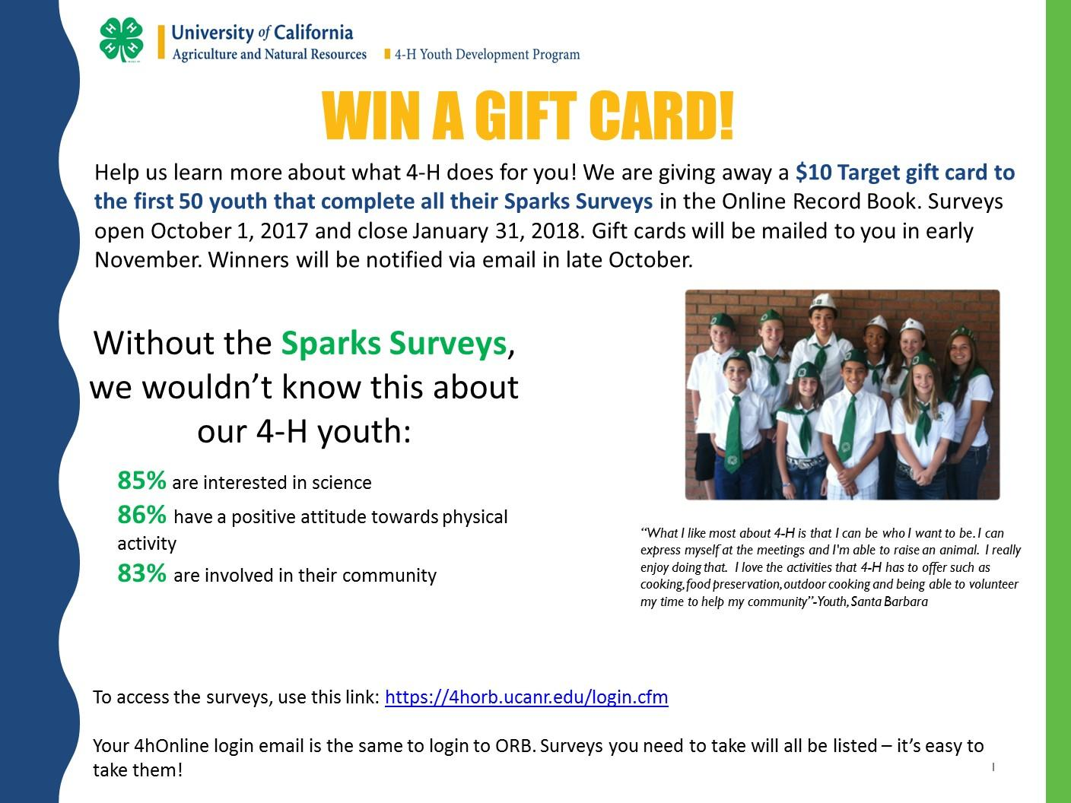



**Become a Shooting Sports Leader**

**4-H Shooting Sports Workshop - Rifle Discipline  
Fallbrook, CA (San Diego County)**

**Saturday, December 16, 2017 – 8:00 a.m. – 6:00 p.m.  
Sunday, December 17, 2017 – 8:00 a.m. – 4:00 p.m.**A 4-H shooting sports workshop for the rifle discipline will be held at Defensive Tactics and Firearms, 504 E. Alvarado Street # 207, Fallbrook, CA. Participants must attend both days of training to receive certification. Upon successful completion of the course, the participant will be certified as a rifle trainer and can lead a rifle project at the club level or serve as county trainer to certify other leaders. The cost for the course is $25 and includes all training material and range fees. The nearest food source is 10 minutes away so it is recommended you bring your own lunch. For information about the course and how it will operate contact John Borba at: [jaborba@ucanr.edu](mailto:jaborba@ucdavis.edu). To register for the course please complete and mail the “CA 4-H Shooting Sports Training Request and Registration Form” available at <http://4h.ucanr.edu/files/4785.pdf>, and an adult (<http://4h.ucanr.edu/files/20100.pdf>) or youth (<http://4h.ucanr.edu/files/4726.pdf>) 4-H medical release form and a **$25 check** payable to “San Diego County 4-H Council and mail to UC Cooperative Extension, 9335 Hazard Way Suite 201, San Diego, CA 92123. Registration is due Friday, 7 days prior to the class and space is limited. Teen leaders are invited but must attend with an adult or have a certified shooting sports adult leader they will be assisting back home. To register contact Debbie McAdams at (858) 822-7735 or email: [damcadams@ucanr.edu](mailto:damcadams@ucanr.edu)

**4-H Shooting Sports Workshops**

If you have an interest in sharing your Shooting Sports skills with youth, how about becoming a 4-H Shooting Sports adult volunteer or teen leader?  There will be a variety of 4-H Shooting Sports leader certification trainings offered this fall. The classes will be held over a Saturday and Sunday weekend format at the Safety First Shooting Association, River Oaks Range, 11584 Shaffer Rd, Winton, in Merced County (center state).   This class is being hosted by Merced County 4-H.   You must become a 4-H leader or member and attend both days to receive certification to lead the shooting sports discipline of your choice at the project, club and camp levels.   The course will include a PowerPoint lecture, review of equipment, practice shooting and teaching, and a written test.   The cost is $35 per person to include a resource binder, with Saturday and Sunday lite breakfast refreshments.   Please bring your own lunch to the class. Junior and teen leaders are invited but must attend with an adult or have a certified shooting sports adult leader they will be assisting back home. Driving directions to the facility are at <http://www.safetyfirstshooting.org/html/directions.html> . Tent or Dry RV camping is an option. Numerous hotels are available in the area, contact Dave below for more info if needed.

To register, please complete and mail the “CA  4-H Shooting Sports Training Request and Registration Form” available at <http://4h.ucanr.edu/files/4785.pdf> with an adult <http://4h.ucanr.edu/files/20100.pdf> or youth <http://4h.ucanr.edu/files/4726.pdf> 4-H medical release form and a $35 check payable to “Merced  County 4-H Council” and mail to UCCE, 2145 Wardrobe Ave, Merced, 95341.  Registration is due Friday the week before your class (7 days prior), **Space is limited to 20 attendees.**   For more information call Dave at 209-614-1718 or Darlene McIntyre at [209-385-7418](mailto:209-385-7418) or email her at [dlmcintyre@ucanr.edu](mailto:dlmcintyre@ucanr.edu).

**Archery** – Sept 9 & 10th **Archery**– Dec 9 & 10th

**Pistol** – Sept 16 & 17th **Pistol**– Dec 9 & 10th

**Western Heritage** – Oct 7 & 8th **Western Heritage** – Jan 6 & 7th

**Muzzle Loading** – Oct 15 & 16th **Muzzle Loading** – Jan 13 & 14th

**Rifle** – Nov 18 & 19th

**Shotgun** – Nov 18 & 19th

**MINDFULNESS RETREAT information at** [**http://4h.ucanr.edu/Projects/HealthyLiving/Mindfulness/**](http://4h.ucanr.edu/Projects/HealthyLiving/Mindfulness/)

[**Register Here**](https://ucanr.edu/survey/survey.cfm?surveynumber=21346)

**Remember Alameda County 4-H will provide a 50% registration fee scholarship for every 4-H teen and adult that attends. Adults will receive a 100% reimbursement. Reimbursements will be made when the delegates return from the conference.**



**Save the Date**



**Western Regional Leaders Forum**

**March 1-4, 2018 in San Diego, CA**

**“Waves of Change"**

This is fondly known as WRLF. This conference was started in California in 1966 as a staff and volunteer joint effort and now some fifteen years later it is still going strong! This conference is a three-day leadership opportunity for county staff and volunteers to share skills and knowledge. The conference is held during the first week of March or the last week in February. One of the thirteen 13 Western States hosts the conference.

This multi-state, educational “volunteer forum” is held every year, hosted by a different state in the western region of the United States (including Alaska and Hawaii). This learning opportunity includes great speakers, skill-building workshops, time to exchange tons of ideas and make new friends, and entertainment just for fun!  Teen 4-H volunteers are welcome too.

The 2018 forum will be hosted by California. The location is the [Crowne Plaza](https://www.crowneplaza.com/hotels/us/en/san-diego/sancp/hoteldetail?qAdlt=1&qBrs=6c.hi.ex.rs.ic.cp.in.sb.cw.cv.ul.vn.ki.sp.nd.ct&qChld=0&qFRA=1&qGRM=0&qIta=99504425&qPSt=0&qRRSrt=rt&qRef=df&qRms=1&qRpn=1&qRpp=20&qSHp=1&qSmP=3&qSrt=sBR&qWch=0&srb_u=1&icdv=99504425&sicreative=170934545942&siclientid=2974&sitrackingid=745012016&dp=true&glat=SEAR) 2270 Hotel Circle N, San Diego, California 92108.

## California 4-H Update Newsletter

**California 4-H State News**

The latest **California 4-H Update** [September 2017](http://4h.ucanr.edu/files/268333.pdf)

Subscribe to receive the California 4-H Update, our monthly newsletter! Stay informed on upcoming events and opportunities for 4-H'ers and volunteers.

[**Subscribe today**](https://visitor.r20.constantcontact.com/d.jsp?llr=ijdnjczab&p=oi&m=1126432148776&sit=yp9r47blb&f=c3eefc2b-f4af-4dfd-9fb0-1a2b8efd846b)**!**

The newsletter is emailed once a month to 4-H members, volunteers and supporters. Members and volunteers can choose to subscribe when they enroll.

If you have questions about the newsletter, please contact Darlene Ruiz at [ca4h@ucanr.edu](mailto:ca4h@ucanr.edu) or 530-750-1334.

BCA%20Update-%20July.pdf

California State 4-H social media

**Follow us on social media for the latest updates on 4-H in California.**

|  |  |
| --- | --- |
|  | **Facebook**  [@California4H](https://www.facebook.com/california4H/)  [@CaPrograma4H](https://www.facebook.com/CaPrograma4H/) (Spanish) |
|  | **Twitter**  @California4H |
|  | **Instagram**  California4H |
|  | **YouTube**  California4H |

It is the policy of the University of California (UC) and the UC Division of Agriculture & Natural Resources not to engage in discrimination against or harassment of any person in any of its programs or activities (Complete nondiscrimination policy statement can be found at http://ucanr.edu/sites/anrstaff/files/215244.pdf )  
Inquiries regarding ANR’s nondiscrimination policies may be directed to John I. Sims, Affirmative Action Compliance Officer/Title IX Officer, University of California, Agriculture and Natural Resources, 2801 Second Street, Davis, CA 95618, (530) 750- 1397.