**State Exchange Project**



Volume 1 | Issue 10

Alameda County

4-H

August 15, 2017

Inside this issue:

State Exchange........ 1 Shooting Sports....... 2

Casting Call……… 3

Mindfulness Retreat 4

Roots & Shoots … 5

WRLF …………... 6

Bay Coast Area News 7

4-H Blast

Alameda County

Created by Cheryl Fraser

4-H Program Representative

Contact information 510-670-5639 or cyfraser@ucanr.edu



4-H State Exchange Project

State Exchange is looking for new members for the 2017-2018 year from Alameda and Contra Costa County 4-H Clubs. It is a county project that allows members to interact with 4-Hers from other states. It is a great opportunity for the members to see how other 4-H communities thrive. See another state and get a chance to host that state right here in California. The members build life time friendships. Age requirements for the project are 12 years old and up. Most funds needed to travel and host are raised through fundraising events. And families must be able to host a visiting member for a week. It is a two year commitment for the project. As we travel one year then host the next. Please call either Selma Michael 510-517-2346 or Marnie Hascall 925-788-4812,



**Become a Shooting Sports Leader**

**4-H Shooting Sports Workshops**

If you have an interest in sharing your Shooting Sports skills with youth, how about becoming a 4-H Shooting Sports adult volunteer or teen leader?  There will be a variety of 4-H Shooting Sports leader certification trainings offered this fall. The classes will be held over a Saturday and Sunday weekend format at the Safety First Shooting Association, River Oaks Range, 11584 Shaffer Rd, Winton, in Merced County (center state).   This class is being hosted by Merced County 4-H.   You must become a 4-H leader or member and attend both days to receive certification to lead the shooting sports discipline of your choice at the project, club and camp levels.   The course will include a PowerPoint lecture, review of equipment, practice shooting and teaching, and a written test.   The cost is $35 per person to include a resource binder, with Saturday and Sunday lite breakfast refreshments.   Please bring your own lunch to the class. Junior and teen leaders are invited but must attend with an adult or have a certified shooting sports adult leader they will be assisting back home. Driving directions to the facility are at <http://www.safetyfirstshooting.org/html/directions.html> . Tent or Dry RV camping is an option. Numerous hotels are available in the area, contact Dave below for more info if needed.

To register, please complete and mail the “CA  4-H Shooting Sports Training Request and Registration Form” available at <http://4h.ucanr.edu/files/4785.pdf> with an adult <http://4h.ucanr.edu/files/20100.pdf> or youth <http://4h.ucanr.edu/files/4726.pdf> 4-H medical release form and a $35 check payable to “Merced  County 4-H Council” and mail to UCCE, 2145 Wardrobe Ave, Merced, 95341.  Registration is due Friday the week before your class (7 days prior), **Space is limited to 20 attendees.**   For more information call Dave at 209-614-1718 or Darlene McIntyre at [209-385-7418](mailto:209-385-7418) or email her at [dlmcintyre@ucanr.edu](mailto:dlmcintyre@ucanr.edu).

**Archery** – Sept 9 & 10th **Archery**– Dec 9 & 10th

**Pistol** – Sept 16 & 17th **Pistol**– Dec 9 & 10th

**Western Heritage** – Oct 7 & 8th **Western Heritage** – Jan 6 & 7th

**Muzzle Loading** – Oct 15 & 16th **Muzzle Loading** – Jan 13 & 14th

**Rifle** – Nov 18 & 19th

**Shotgun** – Nov 18 & 19th

**Kids Baking Championship is casting**

**Casting Call for Food Network Show**

Blair Franklin, Casting Producer for a Food Network show called “Kids Baking Championship” is currently casting ages 8-13 for Season 4 of the show.  
  
It's a super fun show hosted by and Valerie Bertinelli where kid bakers compete in a series of baking challenges for the chance to win an amazing cash prize. The show is seeking talented kids with the ability to bake a variety of different desserts.   
  
If you have any questions, please contact Blair at [bfranklin@sonicdog.com](mailto:bfranklin@sonicdog.com) or Anne Iaccopucci at [amiaccopucci@ucanr.edu](mailto:amiaccopucci@ucanr.edu)   
  
Check out the show:  
<http://www.foodnetwork.com/shows/kids-baking-championship>  
  
Apply:  
<https://bakingchampionshipcasting.castingcrane.com/>  
  
  
Thank you,  
Anne Iaccopucci  
State 4-H Healthy Living Academic Coordinator

**MINDFULNESS RETREAT**



[**Register Here**](https://ucanr.edu/survey/survey.cfm?surveynumber=21346)

**Remember Alameda County 4-H will provide a 50% registration fee scholarship for every 4-H teen and adult that attends. Adults will receive a 100% scholarship attending the conference as a chaperon.**

**Reimbursement will be made when the delegates return from the conference.**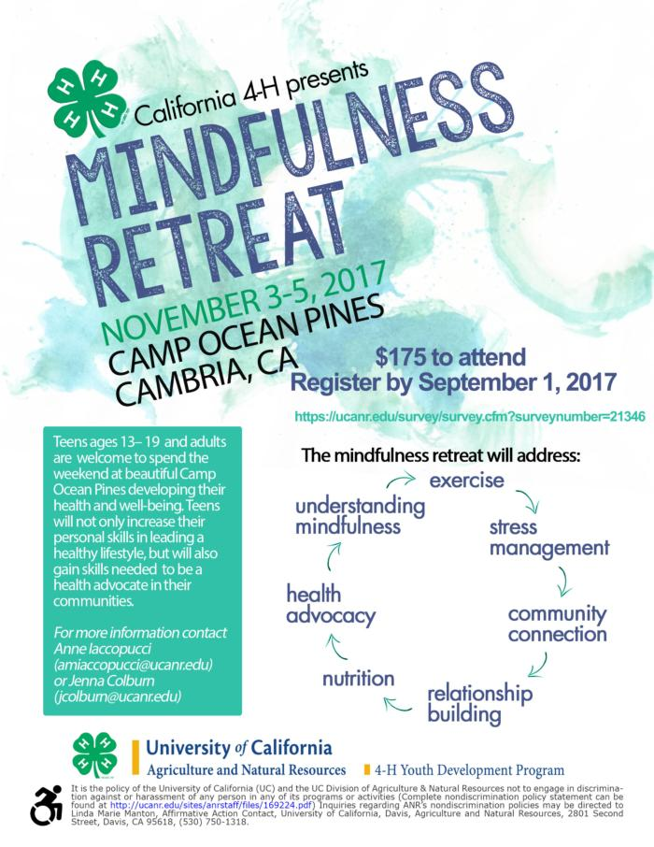

Jane Goodall in San Francisco Oct 11th, - 4-Hers are invited!

Heads up - Roots&Shoots is having a celebration on October 11th in San Francisco for the Institute's 40th anniversary. A save the date card is below Help get the word out to any educators you know in the Bay Area who may be interested in attending? Jane will be there and students will have a chance to present their projects to her. The institute would love to have some GIS projects there. Do you know a 4-Her who would want to take part?

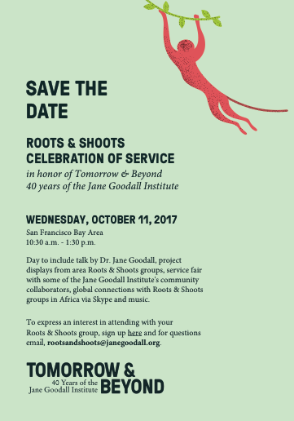

**Save the Date**



**Western Regional Leaders Forum**

**March 1-4, 2018 in San Diego, CA**

**“Waves of Change"**

This is fondly known as WRLF. This conference was started in California in 1966 as a staff and volunteer joint effort and now some fifteen years later it is still going strong! This conference is a three-day leadership opportunity for county staff and volunteers to share skills and knowledge. The conference is held during the first week of March or the last week in February. One of the thirteen 13 Western States hosts the conference.

This multi-state, educational “volunteer forum” is held every year, hosted by a different state in the western region of the United States (including Alaska and Hawaii). This learning opportunity includes great speakers, skill-building workshops, time to exchange tons of ideas and make new friends, and entertainment just for fun!  Teen 4-H volunteers are welcome too.

The 2018 forum will be hosted by California. The location is the [Crowne Plaza](https://www.crowneplaza.com/hotels/us/en/san-diego/sancp/hoteldetail?qAdlt=1&qBrs=6c.hi.ex.rs.ic.cp.in.sb.cw.cv.ul.vn.ki.sp.nd.ct&qChld=0&qFRA=1&qGRM=0&qIta=99504425&qPSt=0&qRRSrt=rt&qRef=df&qRms=1&qRpn=1&qRpp=20&qSHp=1&qSmP=3&qSrt=sBR&qWch=0&srb_u=1&icdv=99504425&sicreative=170934545942&siclientid=2974&sitrackingid=745012016&dp=true&glat=SEAR) 2270 Hotel Circle N, San Diego, California 92108.

## California 4-H Update Newsletter

**California 4-H State News**

The latest **California 4-H Update**: [August 2017 Update](http://4h.ucanr.edu/files/266239.pdf)Subscribe to receive the California 4-H Update, our monthly newsletter! Stay informed on upcoming events and opportunities for 4-H'ers and volunteers.

[**Subscribe today**](https://visitor.r20.constantcontact.com/d.jsp?llr=ijdnjczab&p=oi&m=1126432148776&sit=yp9r47blb&f=c3eefc2b-f4af-4dfd-9fb0-1a2b8efd846b)**!**

The newsletter is emailed once a month to 4-H members, volunteers and supporters. Members and volunteers can choose to subscribe when they enroll.

If you have questions about the newsletter, please contact Darlene Ruiz at [ca4h@ucanr.edu](mailto:ca4h@ucanr.edu) or 530-750-1334.

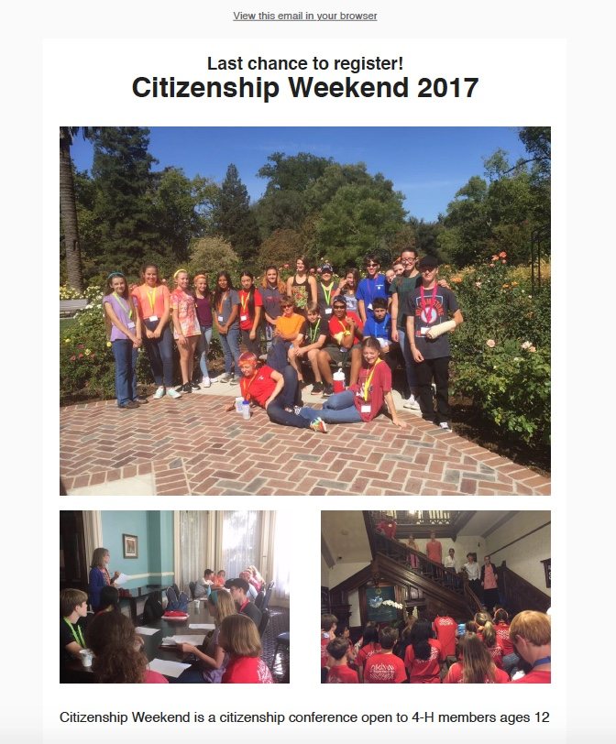

**4-H Bay Coast Area for**

**July and August**

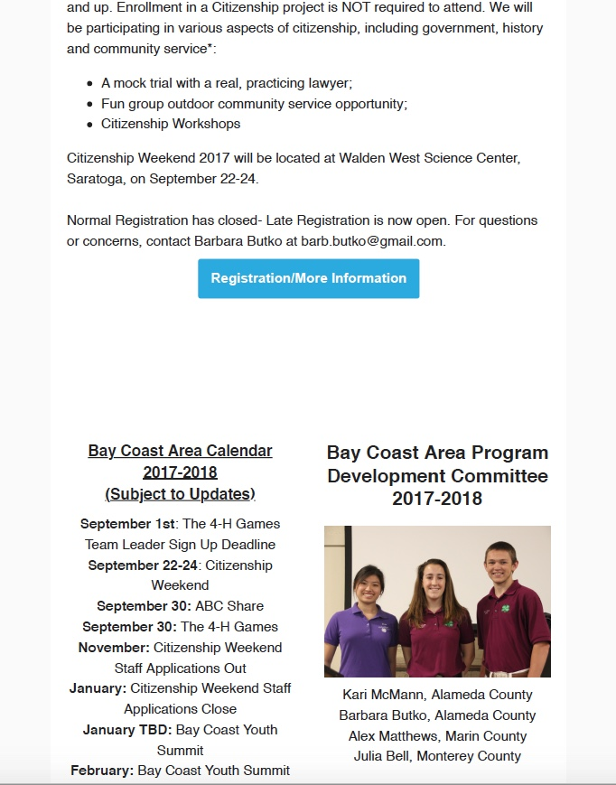

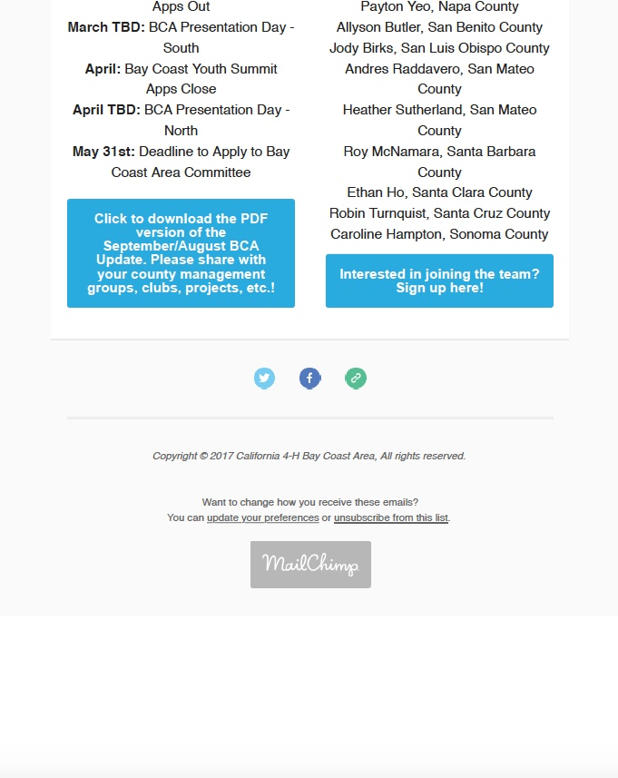

BCA%20Update-%20July.pdf

California State 4-H social media

**Follow us on social media for the latest updates on 4-H in California.**

|  |  |
| --- | --- |
|  | **Facebook**  [@California4H](https://www.facebook.com/california4H/)  [@CaPrograma4H](https://www.facebook.com/CaPrograma4H/) (Spanish) |
|  | **Twitter**  @California4H |
|  | **Instagram**  California4H |
|  | **YouTube**  California4H |

It is the policy of the University of California (UC) and the UC Division of Agriculture & Natural Resources not to engage in discrimination against or harassment of any person in any of its programs or activities (Complete nondiscrimination policy statement can be found at http://ucanr.edu/sites/anrstaff/files/215244.pdf )  
Inquiries regarding ANR’s nondiscrimination policies may be directed to John I. Sims, Affirmative Action Compliance Officer/Title IX Officer, University of California, Agriculture and Natural Resources, 2801 Second Street, Davis, CA 95618, (530) 750- 1397.