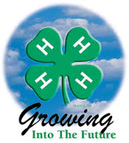

Alameda County 4-H Resource Center http://4halameda.ucanr.edu
224 W. Winton Avenue, Room 134 Hayward, CA 94544

[Office] 510-670-5639 [Fax] 510-670-5671

Cheryl Fraser [Email] cyfraser@ucanr.edu

November 28, 2017

PROGRAM SUPPORT – Cheryl
Call for Science Matters Teen participants and adult leader.
General Description
Alameda and Contra Costa 4-H Programs have been selected to participate in a new nationwide project called Science Matters. Its long-term goal is to drive youth to a pathway that will deepen their understanding of how science connects to their food, animals and health; spark their interest in agri-science careers; and empower them with the skills and support to show their communities just how much science matters.
ADULT AND YOUTH EXPECTATIONS ON THE BACK
Website page with application http://4halameda.ucanr.edu/Projects/
Application Deadline is Wednesday, December 13, 2017

ENROLLMENT - Cheryl

ENROLLMENT DEADLINE: December 1, 2017
If a youth or adult needs an extension to complete the requirements, please let me know their name and length of the extension. Otherwise the enrollment will be removed from the 4hOnline system.
2017/2018 Fees:

Youth - $69.00 ($46 State and $25 County less $2.00 Fentons’ Fee)
Adult - $16.00 ($16 State, $0 County)

Active Adults 180, Active Youth 510
Pending Adults 117, Pending Youth 127
Incomplete Adults 0, Incomplete Youth 8

TRAININGS – Cheryl
2017/2018 Beginning 4-H for Volunteers
- Required for new adult volunteers.
- Beginning 4-H for Volunteers (Orientation); 10:00 AM – 2:00 PM (bring bag lunch)
- Live Scan Available
- LAST TWO TRAININGS
  - December 9 (Pleasant Hill) 10 openings remaining
  - December 10, 2017 (Hayward) 4 openings remaining.
- Register at http://ucanr.edu/beginning4hforvolunteers

FACILITY USE - Lisa
Please remind your project leaders to complete the 4-H Log. Please use the link: http://ucanr.edu/4hlog

OUTREACH – Cheryl
Remember to record your outreach all year long. Please enter online at http://ucanr.edu/outreach
Or fill out the Outreach Methods Documentation form and turn it in monthly.

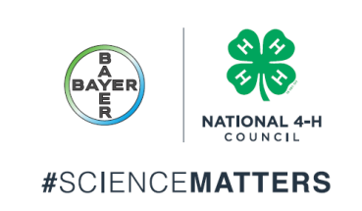

Adult Volunteer:
Activities
- Help build agricultural literacy among urban and rural youth in underserved communities and provide pathways for leadership and service in the field of Agri-science.
- Demystify uninformed perceptions of agriculture and show the impact that advancements in science create for our world.
- Work with a team of 4-5 teen leaders in your community to identify an issue that can be solved through agriculture and science based solutions.
- Science Matters activities include community action planning, implementation, presentation and evaluation.
- The Science Matters Adult Volunteer will be the adult volunteer for all events hosted and/or attended by the unit.
Teen Member:
Activities
- Work as a team to identify and explore an issue that can be solved through agricultural and science based solutions including community action planning, implementation, presentation and evaluation
- Complete the Common Measures survey
- Help to conduct a minimum of two showcases of the Science Matters teams’ skills and knowledge gained
- Create and post stories about Science Matters activities on social media
- Abide by all county, state and national 4-H code of conduct and policies.

Application Deadline is Wednesday, December 13, 2017

