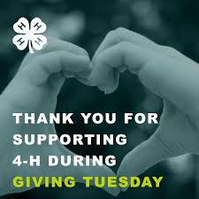

resource Center News

Alameda County 4-H

  - Facebook: https://www.facebook.com/alameda4h/
Website: http://4halameda.ucanr.edu
email: cyfraser@ucanr.edu
November 27, 2018

ENROLLMENT
All returning youth and adults need to be enrolled and in active status by December 1, 2018

2018-2019 ALAMEDA COUNTY FEES: YOUTH $80.00 ($84 less $4.00 from Fenton’s Fund , ADULTS $18.00

Please remind all adults that the last Beginning 4-H for Volunteers is December 15, 2018 in Alameda.
Register at http://ucanr.edu/beginning4hforvolunteers

REQUIRED
LOGGING ALL PROJECT MEETINGS http://ucanr.edu/4hlog
OUTREACH METHODS DOCUMENTATION http://ucanr.edu/outreach

County, State and National Updates
The National Western Stock Show is excited to announce a 4-H and FFA Wool Judging contest. The Contest will take place on Friday, January 18, 2019 outside of Denver, CO. Please feel free to send this information to anyone you think it might be of interest to. California 4-H can enter a maximum of 2 teams. If you have a team that is interested in representing CA, please let me know by December 12. For more information and to register both contests, please visit https://nationalwestern.com/judging-contest/
The latest California 4-H Update: November 2018 Update
Subscribe to receive the California 4-H Update, our state monthly newsletter! Stay informed on upcoming events and opportunities for 4-H'ers and volunteers.
Subscribe today!
The newsletter is emailed once a month to 4-H members, volunteers and supporters. Members and volunteers can choose to subscribe when they enroll.
If you have questions about the newsletter, please contact Suzanne Morikawa at morikawa@ucanr.edu or 530-750-1381.

