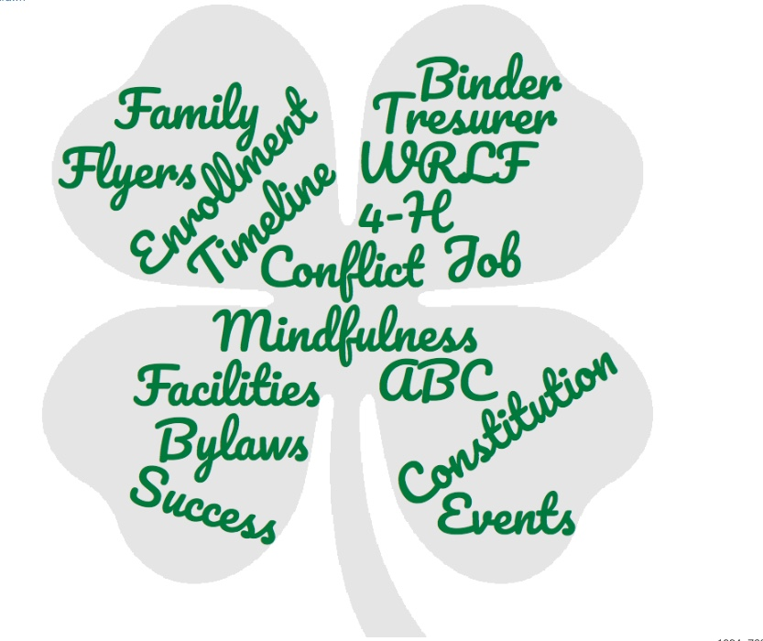

resource Center News

Alameda County 4-H

  - Facebook: https://www.facebook.com/alameda4h/
Website: http://4halameda.ucanr.edu
email: cyfraser@ucanr.edu
  - 510-670-5639
  - January 29, 2019

ENROLLMENT
617 youth and 258 adults are active in 4hOnline and may participate in the 4-H Program.
33 youth and 7 adults are pending and may not participate in the 4-H Program until there status is active.

Spring Beginning 4-H for Volunteers is March 2, 2019 in Contra Costa County.
Register at http://ucanr.edu/beginning4hforvolunteers

REQUIRED
LOGGING ALL PROJECT MEETINGS http://ucanr.edu/4hlog
OUTREACH METHODS DOCUMENTATION http://ucanr.edu/outreach

County Updates
Copyright Infringement: Please be careful when using photos from a website for use in 4-H related publications that will be posted to a website. Copyright laws need to be followed.

Community Club Leader Retreat: We are beginning to plan for a Community Club Leader Retreat. Let me know of any topics you would like to know more about. The date is August 31, 2019.

Alameda County Fair New Rule for still exhibits
All 4-H exhibitors will be compared to the master county 4-H project list to ensure eligibility.
Any 4-H exhibitor not listed in a related 4-H project will be transferred to open youth prior to judging and will not be eligible for 4-H sponsored awards in that category.
This list needs to be updated by May 1, 2019. It will be sent to the fair on May 10, 2019. This will be pertaining to the still exhibits only (baking, photography, arts & crafts, sewing, fine art, gardening, etc.)
What do the members and project leaders need to do?
Member: make sure every project you enter in the fair is listed on your 4hOnline profile.
Project Leader: make sure that you are listed as the project leader and the member is included in your 4hOnline project list. Please email me for the password to your 4hOnline project list or contact your 4-H Club Volunteer Enrollment Coordinator.
National Opportunity Congressional Award This award is available to youth 13 ½ to 24 years old. Past community service does not count. The sooner you register, the sooner your service hours count. For more information go to http://congressionalaward.org/about/. Gold medals are presented in DC and other medals will be presented by your congressman.

