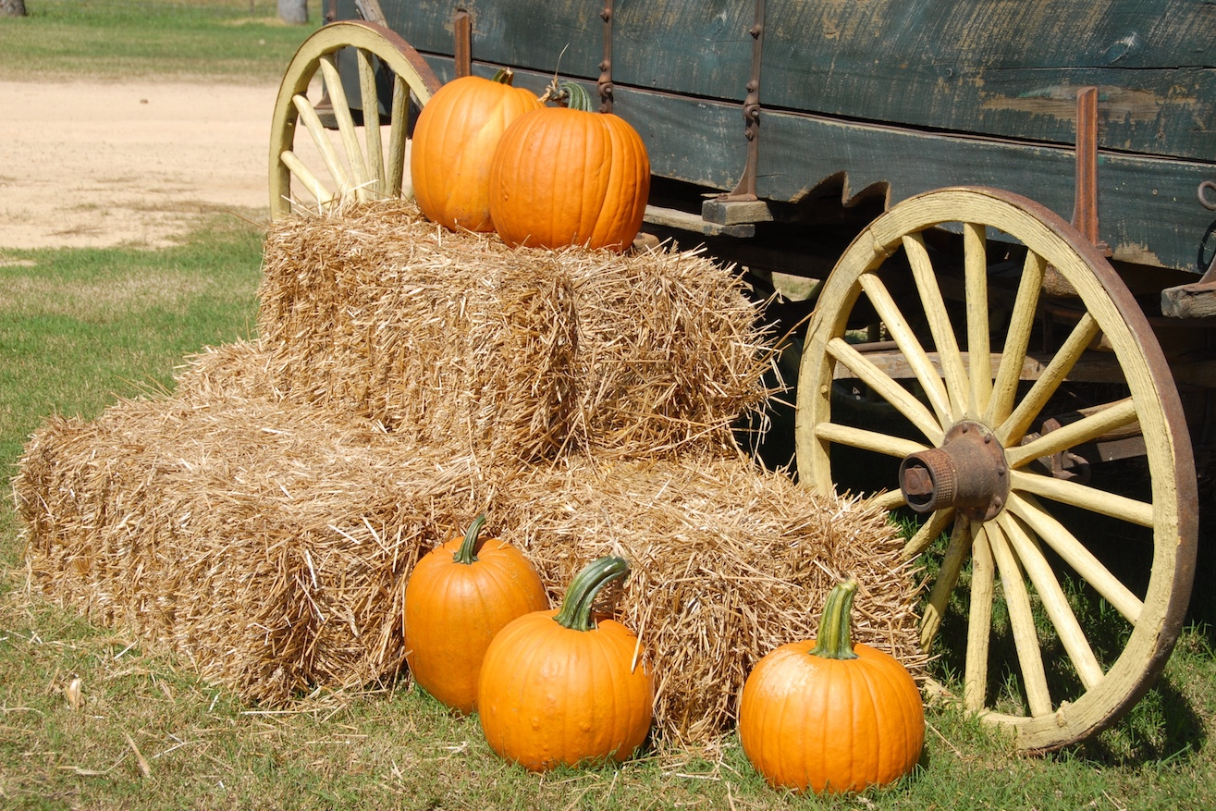
Resource Center News - Alameda County 4-H
  - Facebook: https://www.facebook.com/alameda4h/
Website: http://4halameda.ucanr.edu
email: cyfraser@ucanr.edu
SEPTEMBER 24, 2019

ENROLLMENT
2019-2020 ALAMEDA COUNTY FEES: YOUTH $90.00 ($58 state, $30 county, $2 leaders’ council), ADULTS $24.00 I will send out a list of adults that have completed the online training about every 10 days.
All returning adults and youth must be enrolled by November 30, 2019.
New members must be enrolled by April 1, 2020.
UPCOMING TRAININGS
BEGINNING 4-H FOR NEW VOLUNTEERS are Oct 13 Contra Costa, Nov 16 Alameda, Dec 14 Contra Costa, Dec 15, Alameda. Register at http://ucanr.edu/beginning4hforvolunteers

County, State and National Updates

Mindfulness Retreat Registration and Information￼
4-H Healthy Living Program for youth age 13-19 and adults, November 1-3, 2019 Register by Oct 1, 2019.

State Record Book and Evaluators needed Record Books are due to the County Office by October 18, 2019. I have to scan the books and include a county form.
Please read the instructions at http://4h.ucanr.edu/Resources/Member_Resources/RecordBook/RBCompetition/StateCompetition/

4-H Week National 4-H Week October 6-12, 2019 http://4h.ucanr.edu/News/?calitem=460648&g=86993

4-H Spirit Day October 6-12, 2019

4-H National Youth Science Day The National Youth Science Day (NYSD) celebration kicks off October 1st and takes place through the month of October. http://4h.ucanr.edu/4-H_Events/NYSD/

Youth Summit Youth can attend any of the 4 summits, not just the one hosted in their Area. Learn more and get updates on the 4-H Youth Summits event page.

Countywide Projects
Redwood 4-H Club | Tech Project | redwood4h.org
Redwood 4-H Club | Guide Dogs | redwood4h.org.
Del Arroyo 4-H Club | Square Dancing | https://delarroyo4h.org/projects/

