4-H News Blast for June 17, 2016
New check request for reimbursement from Alameda County 4-H Club Council is online at http://4halameda.ucanr.edu under the Resources, Volunteer Resources. Please complete and mail in the request to the address on the form.
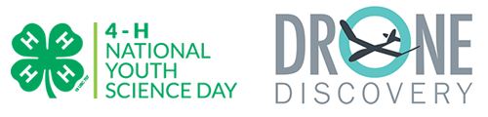
Developed by Cornell University Cooperative Extension, the 2016 4-H National Youth Science Day Challenge: Drone Discovery will explore how remote sensing can be used to solve real world problems while learning concepts like flight dynamics, forces of flight, basic computer coding, as well as following federal regulations while operating drones. Learn more about this year's 4-H NYSD Challenge.

Thank you to our national sponsors: HughesNet, Lockheed Martin and U.S. Cellular.
* Free Shooting Sports Training – Rifle
4-H Shooting Sports Workshop - Rifle Discipline
Where: Dale Wimp Rifle Range, 7398 Avenue 328, Visalia, CA
For information about the facility and a map, please visit the range website at: http:// www.vsma.us/vsma/locations
When: Saturday, June 25, 2016 – 8:00 a.m. – 6:00 p.m. Sunday, June 26, 2016 – 8:00 a.m. – 4:00 p.m.
Certification: Participants must attend both days of training to receive certification. Upon successful completion of the course, the participant will be certified as a rifle trainer and can lead a rifle project at the club level or serve as county trainer to certify other leaders.
Cost: There is no cost for the course. Complimentary lunches will be provided.
For more information, contact John Borba at: jaborba@ucanr.edu
Thank you for your time. Please contact me if you have any questions. Have a wonderful weekend
Cheryl Fraser
4-H Program Representative
510-670-5639

