4-H Blast

Calendar http://4halameda.ucanr.edu/Calendar/
8/27 Annual Treasurer Training
8/30 August Leaders’ Club Council Meeting
9/10 Record Book Evaluation
9/11 Solano Avenue Stroll in Berkeley

4-H Shooting Sports Trainings
Merced County
The Merced County 4-H Shooting Sports training team will be offering a series of project leader and leader trainer classes in rifle, pistol, shotgun, muzzle loading and archery offered from September to December in Central California. All classes will be in a Saturday and Sunday format, 9 AM –4 PM, at the Safety First Shooting Association, River Oaks Range, 11584 N. Shaffer Rd, Winton 95388, in Merced County. Participants must become a 4-H leader or member and attend both days to receive certification to lead any of the shooting sports disciplines at the project, club and camp levels. The course will include a PowerPoint lecture, review of equipment, practice shooting and teaching, and a written test. The cost for each discipline is $35 per person to include a resource binder, with Saturday and Sunday lite breakfast refreshments. Dry camping is available on site as is self-contained RV camping. You are responsible for lunches. The nearest shopping is 15 minutes away. It is recommended to bring lunches each day. You may bring your own firearms and ammunition or archery equipment. However everything will be provided if you want to use their equipment. Junior and teen leaders are invited but must attend with an adult or have a certified shooting sports adult leader they will be assisting back home.

Driving directions to the classrooms and range are at http://www.safetyfirstshooting.org/html/directions.html

To register, please complete and mail the “CA 4-H Shooting Sports Training Request and Registration Form” available at http://www.ca4h.org/files/2123.pdf, and an adult or youth 4-H medical release form and a $35 check payable to “Merced County 4-H Council” and mail to UCCE, 2145 Wardrobe Ave, Merced, 95341. Registration is due Friday, 7 days prior to the class you are taking, and space is limited to 25 attendees. For more information call Darlene McIntyre at 209-385-7418or email her at dlmcintyre@ucanr.edu. Range and class info contact is Dave Givens 209-614-1718 or dave@hammerstryke.com

Class Dates:
Rifle Leader
Sept 17th and 18th (Registration due Sept 9th)
Nov 5th and 6th (Registration due Oct 28th)

Shotgun Leader
Sept 17th and 18th (Registration due Sept 9th)
Nov 19th and 20th (Registration due Nov 11th)

Archery Leader
Oct 8th and 9th (Registration due Sept 30th)
Nov 5th and 6th (Registration due Oct 28th)

Pistol Leader
Oct 8th and 9th (Registration due Sept 30th)
Nov 19th and 20th (Registration due Nov 11th)
Muzzle Loading Leader
Oct 29th and 30th (Registration due Oct 21st)
Dec 10th and 11th (Registration due Dec 2nd)

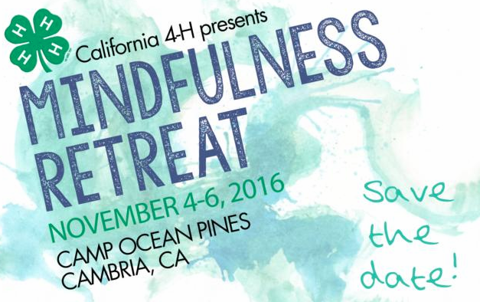The State 4-H Office is thrilled to announce that the first ever CA 4-H Mindfulness Retreat will be held at Camp Ocean Pines in Cambria, CA November 4-6th. Registration is now open and due September 1, 2016. The retreat is designed for both youth and adult participants. Please see registration for details and descriptions on adult participation vs. adult chaperones.
https://ucanr.edu/survey/survey.cfm?surveynumber=18271
Contact Anne Iaccopucci at amiaccopucci@ucanr.edu with any questions.

UC California Naturalist Conference
Hi Everyone,
I would like to send out information regarding a great opportunity to gain a better understanding of California's diverse natural ecosystems in regards to Environmental Education. The UC California Naturalist Conference features a full slate of presenters that include an award winning environmental journalist and science writer, an internationally renowned conservation scientist, a Latino educator and visionary, and a Southern California leader developing community green spaces in underserved neighborhoods. The conference flier and agenda will be posted in the documents section.
**Please feel free to give this information to any volunteers who would be interested in learning more about Environmental Education**

Registration open for the UC California Naturalist Conference
Sept. 9-11 at Pali Mountain Retreat and Conference Center in Running Springs.
“The beautiful mountain setting is the ideal place for California Naturalists to come together to enhance their skills and connect with fellow naturalists,” said Adina Merenlender, co-director of the University of California's California Naturalist Program and conference chair. “We promise a captivating weekend for observing nature, fostering partnerships with other naturalists and organizations, and planning for global climate change.”

Registration for the conference is $170 for certified California Naturalists; for non-certified participants registration is $195. Room and board at Pali Mountain is $165 per person. Those not staying at Pali Mountain pay a $90 food and beverage fee. For more information and to register, visit the conference website, http://calnat.ucanr.edu/2016conference.
Conference attendees may also register for optional advanced training courses that take place on Friday, Sept. 9. The advanced training topics are:
- California's Venomous Animals: Fact & Fiction
- How to Draw like a Naturalist
- iNaturalist 202: Monitoring, Exporting Data, Best Practices for Projects
- Smartphone GPS and Mapping Skills Development Workshop
- The Power of Direct Engagement with Nature: Outdoor Science Instruction
- The California Phenology Project: Tracking the Effects of Climate on the Seasonal Cycle of Wild Plants
Optional field trips are offered in conjunction with the conference. The field trips will be at the end of the conference, on Sunday, Sept. 11. The field trips are as follows:
- From Mountain to City: Tour of the Santa Ana Watershed
- UC Riverside Botanic Gardens
- Unique Plant Communities and Geology of Bear Valley
- The National Children's Forest
- Transitional Plant Communities at Oak Glen Preserve and the Montane Botanic Garden
- A River in the High Desert: Tour of Whitewater Preserve

Jessica Bautista, PhD
Youth, Families, & Communities Statewide Program
4-H STEM Academic Coordinator
University of California, Agriculture & Natural Resources
California State 4-H Office
2801 Second Street
Davis, CA 95618-7774
jbautista@ucanr.edu | (530) 750-1341

